IT 497 LAB 6

library(ggplot2)  
dat<-ggplot2::mpg

# Tranforming the variables in factor with the transform() function  
dat <- transform(dat, cyl = factor(cyl), drv = factor(drv), fl = factor(fl), year = factor(year), class = factor(class))

# Question 1  
ggplot(dat) + aes(x = displ, y = hwy) + geom_point()

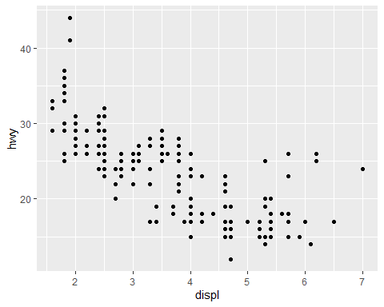

# Question 2  
ggplot(dat) + aes(x = hwy, color = drv, fill = drv) + geom_density(alpha = 0.25) # add transparency

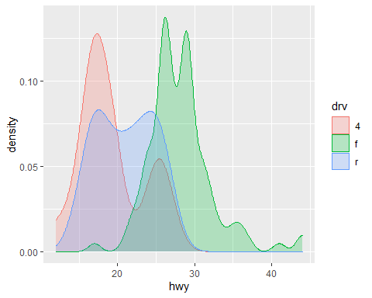

# Question 3  
ggplot(dat) + aes(x = drv, y = hwy) + geom_boxplot(varwidth = TRUE) + geom_jitter(alpha = 0.25, width = 0.2)

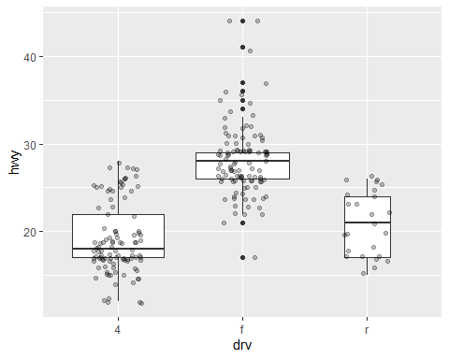

# Question 4  
p <-ggplot(dat) + aes(x = displ, y = hwy) + geom_point()   
  
p + geom_text(aes(label=rownames(dat)), check_overlap = TRUE, size = 2, vjust = -1)

